Major Project Report on

# JUTTA SANSAAR: E-Commerce Website for Footwear Retailing

Submitted in partial fulfillment of the requirements for the degree of

**Bachelors of Engineering in Information Technology**

under Pokhara University

Submitted by:

**Gaurav Pandey, 231420**

**Binod Baduwal, 231415**

**Yugesh Man Shrestha, 231448**

Under the supervision of

**Er. Simanta Kasju**

**Er. Manil Vaidhya**

**Date:**

1st Aug,2025

** Department of IT Engineering**

NEPAL COLLEGE OF INFORMATION TECHNOLOGY

Balkumari, Lalitpur, Nepal

## **ACKNOWLEDGEMENT**

*This project would not have been possible without the joint efforts of many individuals. It has been a pleasure for us to acknowledge the assistance and contributions that were very important and supportive throughout the project. We would like to thank them sincerely.*

*We are indebted to our project supervisor* ***Er. Simanta Kasaju*** *&* ***Er. Manil Vaidhya*** *for his guidance and support throughout the project development period which helped our project to grow and foster to a level we didn‟t think of reaching in such a short period of time.*

*Last, but not the least, we would like to thank our teachers and colleagues who have been knowingly or unknowingly the part of this project with their views during the entire development time.*

## **ABSTRACT**

*The "Jutta Sansaar" project is a dynamic, user-friendly eCommerce shoe store website built using modern web technologies such as HTML, CSS, JavaScript, PHP, and MySQL. The platform aims to simplify the online shoe shopping experience by offering a dedicated, user-friendly, and secure environment for customers to browse, filter, and purchase a wide range of shoes for men, women, and children. Unlike general e-commerce platforms, Jutta Sansaar will provide specialized features tailored to footwear retail, such as category-specific filters and a clean, focused interface.*

*The project is developed using Incremental software development methodology, ensuring flexibility, continuous improvement. The application is responsive, session-based, and focuses on intuitive navigation and security. With distinct modules for user registration, login, product browsing, shopping cart, and checkout, the system streamlines the shopping experience while providing an admin panel for efficient product and order management. The website architecture ensures modularity, scalability, and future expansion capabilities such as payment gateway integration, order tracking, and AI-based recommendations.*

## **TABLE OF CONTENTS**

1. INTRODUCTION 3
   1. PROBLEM STATEMENT 3
   2. OBJECTIVES 3
   3. PROJECT SCOPE AND LIMITATIONS 4
      1. SCOPE 4
      2. LIMITATIONS 4
   4. SIGNIFICANCE OF STUDY 4
2. LITERATURE REVIEW 5
3. TEAM MEMBERS AND DIVIDED ROLES 6
4. METHODOLOGY 7
   1. SOFTWARE DEVELOPMENT LIFE CYCLE 7
      1. REQUIREMENT PHASE 8
      2. ANALYSIS AND DESIGN PHASE 8
      3. IMPLEMENTATION 8
      4. TESTING 8
      5. EVALUATION 8
   2. WHY ITERATIVE MODEL? 9
   3. TOOLS USED 9
5. REQUIREMENT ANALYSIS 10
   1. SYSTEM REQUIREMENT SPECIFICATION 10
      1. FUNCTIONAL REQUIREMENTS 10
   2. NON FUNCTIONAL REQUIREMENTS 10
   3. SECURITY REQUIREMENTS 11
6. SYSTEM DESIGN AND UML MODELS 12
   1. SYSTEM ARCHITECTURE 12
   2. USE CASE DIAGRAM 13
   3. PROCESS FLOW DIAGRAM 14
   4. SCHEMA DIAGRAM 16
7. TESTING 17
   1. TESTING TABLE 17
   2. TESTING EVIDENCE THROUGH SNAPSHOTS 18
8. PROJECT TASK AND TIME SCHEDULE 23
   1. GANTT CHART 23
9. FUTURE EXTENSIONS 23
10. CONCLUSION 24
11. REFERENCE 25

APPENDIX 26

## **INTRODUCTION**

The rapid growth of digital commerce has transformed the way consumers shop for products, especially in the fashion and lifestyle sectors. Among these, footwear holds a significant market share, yet many online platforms lack specialization and personalized experiences tailored to shoe buyers.

Jutta Sansaar is an E-commerce platform where we ease up the Retailing process of Shoes of our desire. A proposed online e-commerce platform specializing in selling a wide variety of shoes for men, women, and children. The website aims to provide a user-friendly, responsive, and secure platform where customers can browse, select, and purchase footwear online with ease. The platform aims to offer a curated selection of shoes for men, women, and children, combining quality, variety, and affordability under one digital roof.

### **PROBLEM STATEMENT**

With the advancement in the technology, android or webpages has been one of the most effective platform for day to day applications . Many people find it difficult to buy the right shoes online because most websites are either too complicated or not focused only on footwear. Big e-commerce sites have too many categories, which makes it hard for users to find exactly what they need. At the same time, smaller shoe sellers struggle to reach online customers due to a lack of proper platforms. There is a need for a simple, dedicated website that focuses only on shoes, making it easy for customers to browse, choose, and buy, while also helping sellers manage their products and orders efficiently.

### **1.2. OBJECTIVES**

The drawbacks mentioned in problem statements need to be solved, for which a new and easier method to be derived. Jutta Sansaar: An E-commerce website for footwear retailing is such an website where the users can browse from the products and view from categories and order products as their likes. Following are the objectives of this project:

1. Design a simple and user-friendly interface that allows customers to easily search, filter, and purchase footwear.
2. Enable user authentication and profile management.
3. Implement product browsing, filtering, cart, and checkout modules.
4. Provide an admin dashboard for inventory and order control.

### **. PROJECT SCOPE AND LIMITATIONS**

The scope of this project is to provide user with all the services through the Ecommerce Website that is created for Footwears Retailing . In this project, a Website will be developed where users of the website will be able to browse, view and order their preferred pair of Shoes.

### **SCOPE**

* + - 1. Web-based platform with customer and admin interfaces.
      2. Multiple product categories (casuals, boots, sandals, etc.).

### **LIMITATIONS**

* + - 1. No integrated payment gateway.
      2. No Delivery Tracking System.

### **SIGNIFICANCE OF STUDY**

This project is proposed with the intention to develop an E-commerce Website of the Footwear Retailing where users can browse the products and order shoes of their choice from website. This project facilitates local retailers' digital transformation, enhances customer experience, and supports the growing trend of online shopping, especially in footwear retailing.

# LITERATURE REVIEW

Existing e-commerce platforms like **Daraz** [1] **and Amazon** [2]have established themselves as large-scale online marketplaces that offer a wide variety of products, including footwear. While they provide global reach, advanced logistics, and secure payment systems, these platforms are not specifically focused on shoes. As a result, customers often face difficulties in finding the right type, size, or style of footwear due to cluttered interfaces and overwhelming product categories. The lack of specialized filters for footwear, such as arch type, shoe width, or activity-specific use (e.g., running, hiking, formal), further reduces the ease of decision-making for users.

Moreover, small and medium shoe retailers find it challenging to compete on platforms like Amazon and Daraz due to high competition, complex seller policies, and commission charges. These platforms prioritize top-performing sellers, making visibility and customer reach difficult for newer or local brands. There is also minimal personalization in the shopping experience. A dedicated shoe-based e-commerce platform like **Jutta Sansaar** can fill these gaps by offering a focused catalog, better product discovery, and features tailored specifically to the needs of shoe buyers and sellers.

## **TEAM MEMBERS AND DIVIDED ROLES**

|  |  |
| --- | --- |
| TEAM MEMBERS | ROLES |
| Gaurav Pandey | UI & UX, Session and some part of Database of index, products, cart, checkout etc.  Documentation |
| Yugesh Man Shrestha | UI & UX of Admin Database and some part of Database of admin, logout etc  Diagrams: User-case, Flow, Schema |
| Binod Baduwal | Due to unavailability of Personal Laptop, Helped us in Idea management and integration and developing.  Documentation |

**Table 1: Divided roles and responsibilities**

1. **METHODOLOGY**

In this section we have described about the method that we will be using to meet the requirement of the project.

### **. SOFTWARE DEVELOPMENT LIFE CYCLE**

The model to be used for developing of this project is Incremental(Iterative) model of SDLC. Iterative model is simple and emphasizes on initial and simple implementation and with progress in the project it gains more feature. It is advantageous since it has unique feature of repetitive nature i.e. during development phase one can go back to check out the previous works without any complications and flaws can be improved if any. Further explanation about the model has been described below.

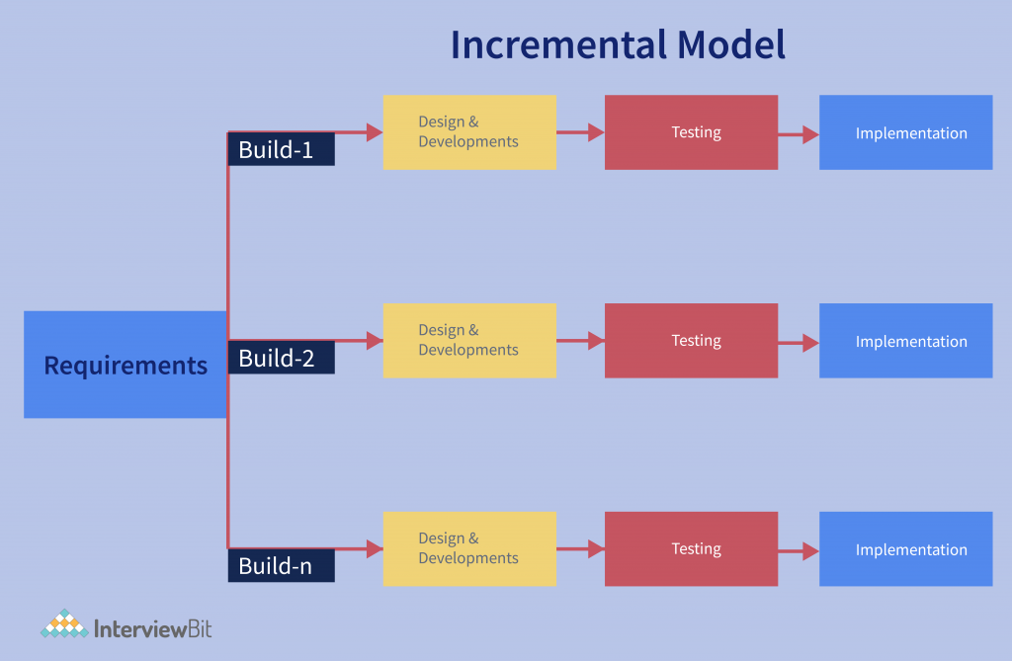

**Figure 1: Incremental Model Approach**

### **REQUIREMENT PHASE**

In this phase, all the necessary requirements are analysed. Till now necessary requirement for further analysis of project is gathered from end-user, Internet and Market situation. And as a result, final specification of the project will be gained.

* + 1. **ANALYSIS AND DESIGN PHASE**

In this phase, the specification gathered is designed as per the requirement. Further the database models, technical requirement and the logic will be implemented in the project.

* + 1. **IMPLEMENTATION**

After the analysis and design the coding is done according to the specifications. Coding is in progress and hence a working system will be obtained in this phase.

* + 1. **TESTING**

Once a system is developed series of testing will be performed in order to remove bugs and errors. Till now some of the functionalities have been developed and tested which is described below in the testing section of this project. Also in this phase certain changes, if necessary, will also be applied to obtain complete and successful system.

* + 1. **EVALUATION**

Evaluation is the last step performed after all the prior steps, where the project will be evaluated to check if it meets the specification or not.

Our project which implements iterative model comprises of following way which are discussed below:

For the development of the Jutta Sansaar eCommerce footwear website, the Incremental Software Development Model was adopted. This model supports systematic development through iterative cycles and allows continuous refinement based on stakeholder feedback.

Each core module of the project such as user authentication, product listing, cart, checkout, and admin functionalities was developed and tested independently, one after another. This modular development approach allowed early delivery of partial functionality and continuous improvements without halting the workflow.

Throughout the development lifecycle, features like session handling, product filtering, and user profile management were repeatedly reviewed, tested, and updated to enhance usability and performance. The Incremental model's flexibility supported integration of feedback at each stage, which led to a more stable, secure, and user-focused system.

Compared to the linear Waterfall model, the Incremental approach allowed our team to work on separate modules simultaneously and integrate them step-by-step, reducing development time while maintaining high-quality standards.

### **WHY ITERATIVE MODEL?**

* Requirements can be changed if necessary by going back to the previous phases without any effect to the further ongoing process.
* This project is based on API so, iterative testing and implementation is required.

### **TOOLS USED**

|  |  |
| --- | --- |
| TOOLS | PURPOSE |
| PHP | Facilitate server-side web development |
| Github | To manage Source Code |
| CSS | Styling of Webpages |
| Javascript | Add interactivity and dynamic behavior to webpages |
| HTML | Structure Content on Webpages |
| XAMPP | Host Webpages |
| MYSQL | Management of Databases |
| VSCode | Text Editor |

**Table 2: Tools used**

1. **REQUIREMENT ANALYSIS**

Requirement analysis, in software engineering encompasses those tasks that go into determining the need and conditions to meet for a new or altered product, taking account of possibly conflicting requirements of the various stakeholders, such as beneficiaries and users.

### **SYSTEM REQUIREMENT SPECIFICATION**

### **FUNCTIONAL REQUIREMENTS**

|  |  |  |
| --- | --- | --- |
| **ID** | **REQUIREMENT** | **PRIORITY** |
| 1 | User is able to view Products | High |
| 2 | User must be logged in to add-to-cart or checkout | Essential |
| 3 | Admin can manage users | Optional |
| 4 | User is able to log out of the website | Optional |
| 5 | User must be connected to the internet | Essential |
| 6 | User is able to view his product in the cart | Essential |

**Table 3: Functional Requirements**

### **NON FUNCTIONAL REQUIREMENTS**

|  |  |  |
| --- | --- | --- |
| **ID** | **REQUIREMENT** | **PRIORITY** |
| 1 | The system works on Android Phone | Optional |
| 2 | The application should be user friendly | Essential |
| 3 | Applications need to operate successfully within a wide spectrum of operating conditions, such as a range of supported screen resolutions and form factors. | Desirable |
| 4 | Application should emphasize on High Performance, High Responsiveness, Good Scalability, Good Usability, High Reliability, Good Security, Modifiability and Maintainability. | Desirable |

**Table 4: Non-functional Requirements**

### **. SECURITY REQUIREMENTS**

Security was a priority during system design and implementation. The following measures were taken to ensure safe handling of user data and protection against common threats:

* **Authentication**:  
  Session-controlled login system restricts access to authenticated users only.
* **Input Validation**:  
  All form fields are validated on both client and server sides to prevent SQL injection and XSS attacks.
* **Session Management**:  
  Session timeout and logout functionality implemented for secure access control.
* **Access Control**:  
  Role-based redirection prevents unauthorized access to admin panels or restricted pages.

## **SYSTEM DESIGN AND UML MODELS**

### **. SYSTEM ARCHITECTURE**

### **Jutta Sansaar** uses a **3-tier architecture**, which separates the application into three main layers:

### 1. **Presentation Layer (Frontend)**

* Built using **HTML, CSS, JavaScript**.
* Handles user interaction.
* Provides product display, login/signup forms, cart view, etc.

### 2. **Application Layer (Backend)**

* Developed in **PHP**.
* Handles business logic: login verification, product filtering, order processing, admin functions.
* Acts as a bridge between the frontend and the database.

### 3. **Data Layer (Database)**

* Built using **MySQL**.
* Stores all persistent data like:
  + Users
  + Products
  + Orders
  + Cart Items
  + Admin data

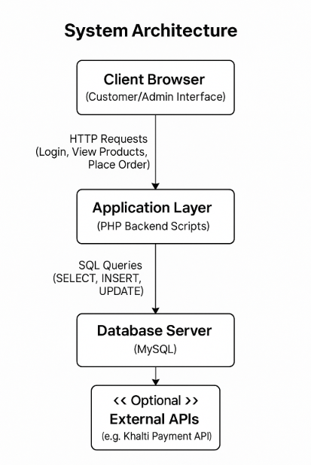

### **6.2. USE CASE DIAGRAM**

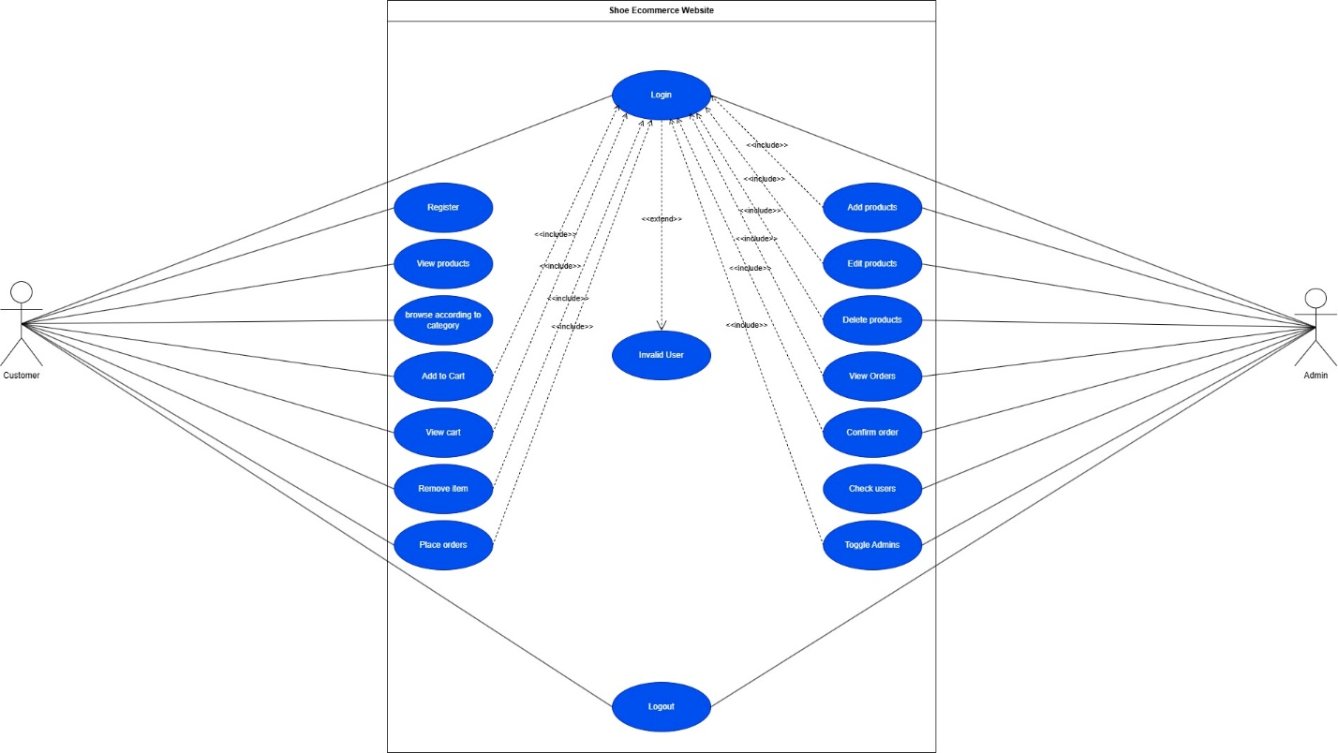

### **6.3. PROCESS FLOW DIAGRAM**

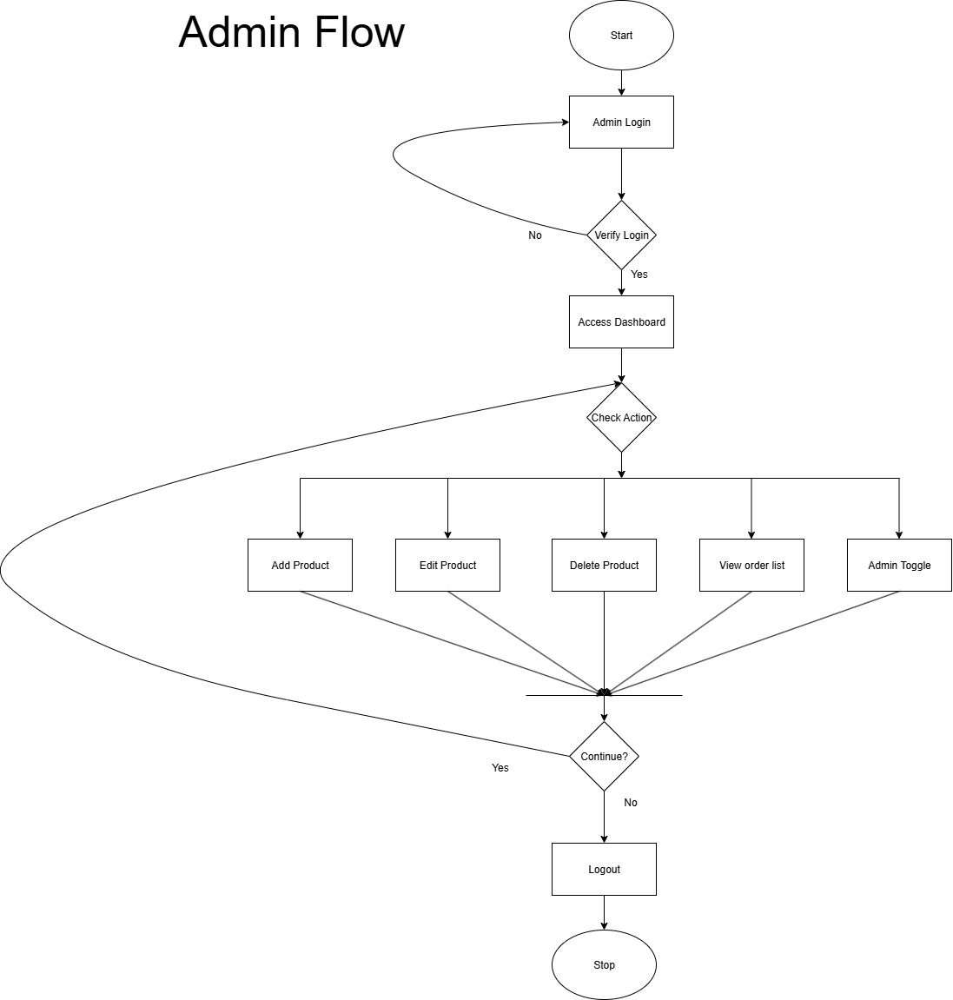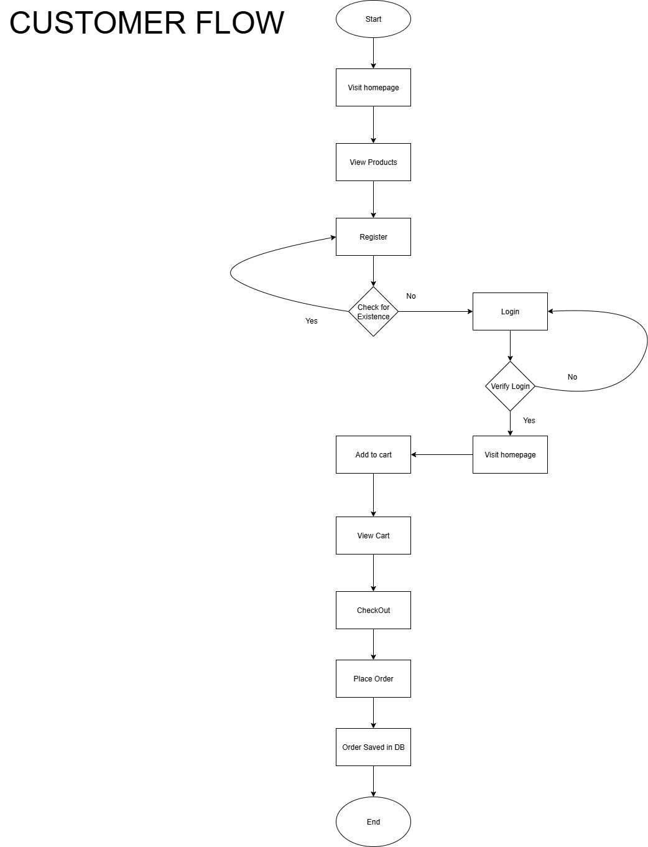

### **6.3. SCHEMA DIAGRAM**

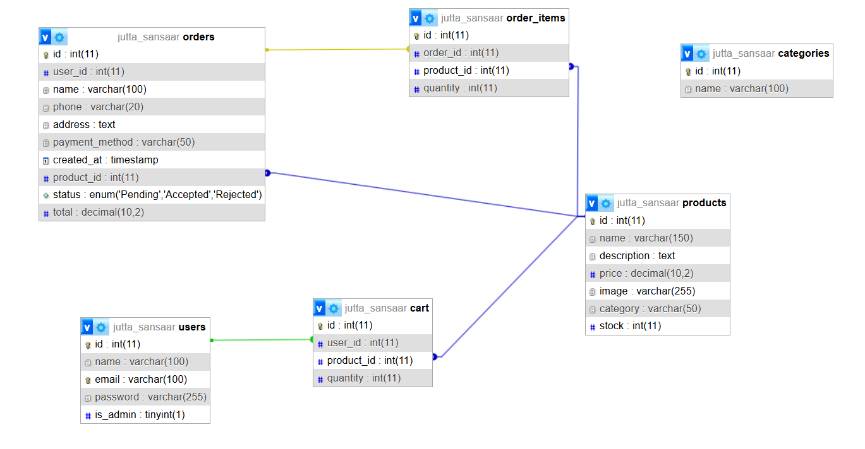

1. **TESTING**

The task done so far has been tested. The below table shows the detailed explanation of the testing carried out.

**7.1. TESTING TABLE**

|  |  |  |  |
| --- | --- | --- | --- |
| Test ID | Module | Expected Result | Status |
| 1 | User Registration | User registered and redirected to login page | Pass |
| 2 | Login | Loads Home Page | Pass |
| 3 | |  | | --- | |  |  |  | | --- | | Product Browsing | | Products displayed with filters and categories | Pass |
| 4 | Add to Cart | Product added to cart | Pass |
| 5 | Cart Management | Cart total updates accordingly | Pass |
| 6 | Checkout | Shows message “Order Placed Successfully” | Pass |
| 7 | Admin Login | Admin dashboard loads | Pass |
| 8 | Admin Product Management | Product added and shown in product list | Pass |
| 9 | Admin Product Management | Products edited and updated | Pass |
| 10 | Admin Product Management | Products Deleted and removed | Pass |
| 11 | Security | Session Expires within 15 min of no activity and user redirected to login page | Pass |
| 12 | Administrative privileges | Admin toggles admin access to other non admin users | Pass |
| 13 | Logout | Session destroyed and redirected to login | Pass |

**Table 5: Testing Table**

### **7.2. TESTING EVIDENCE THROUGH SNAPSHOTS**

INDEX PAGE

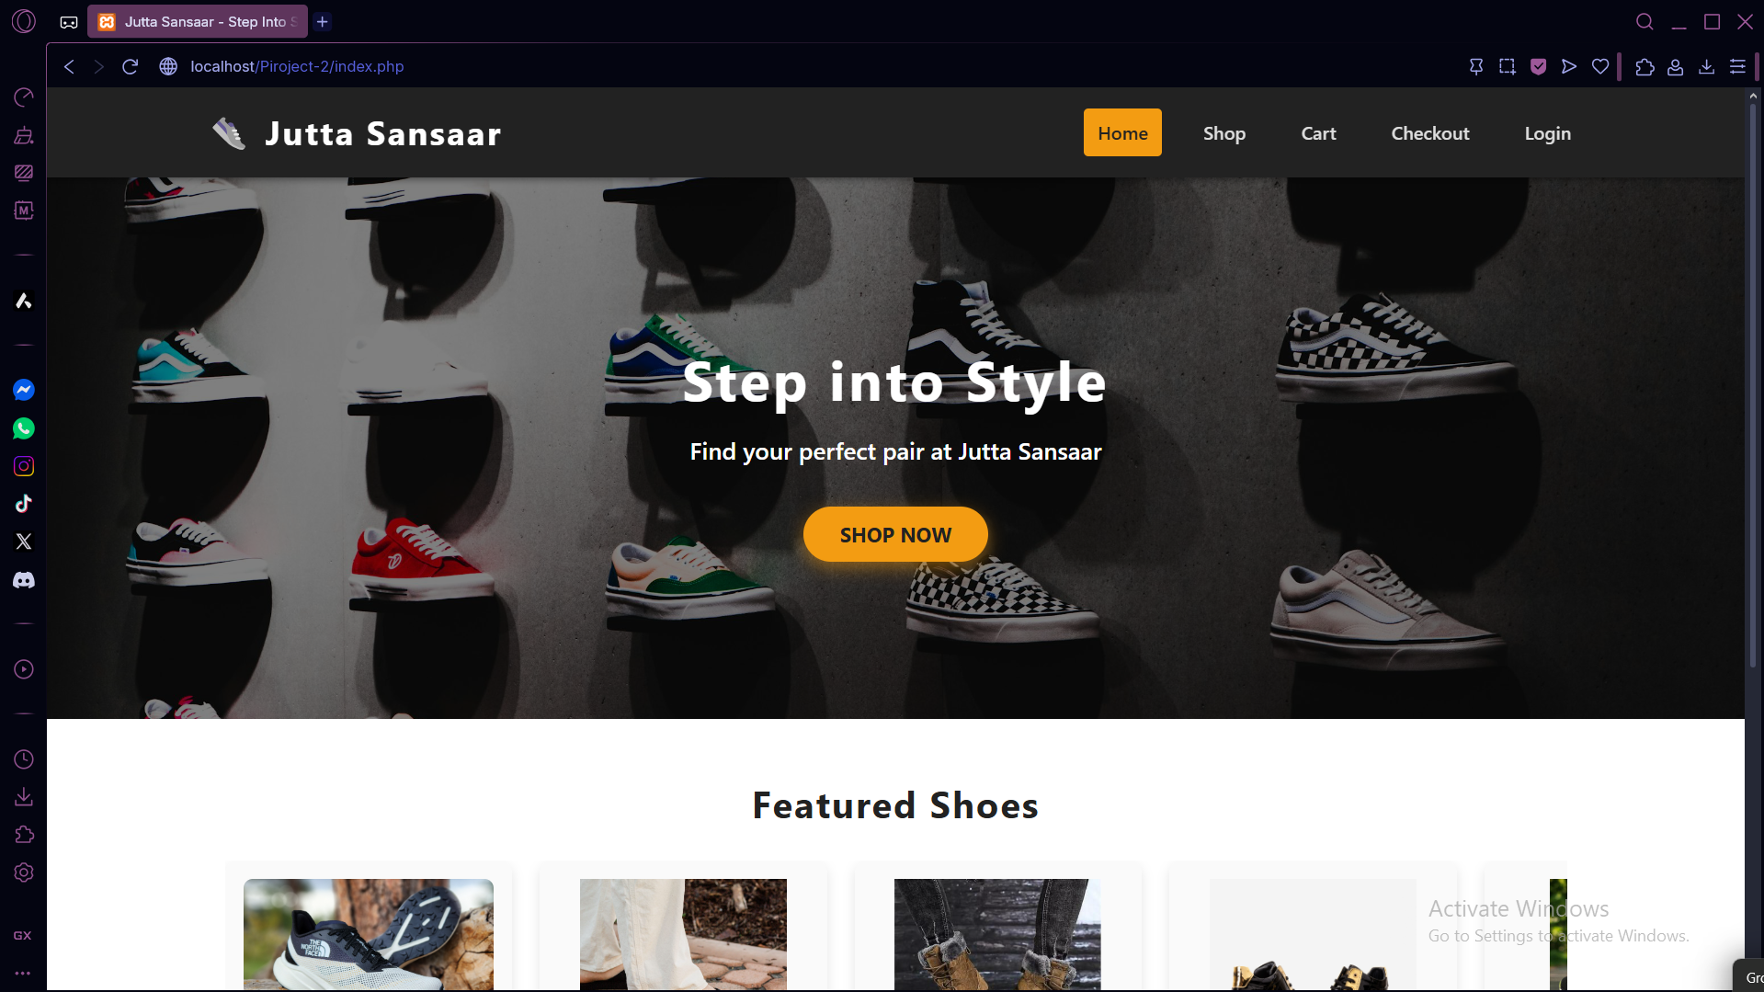

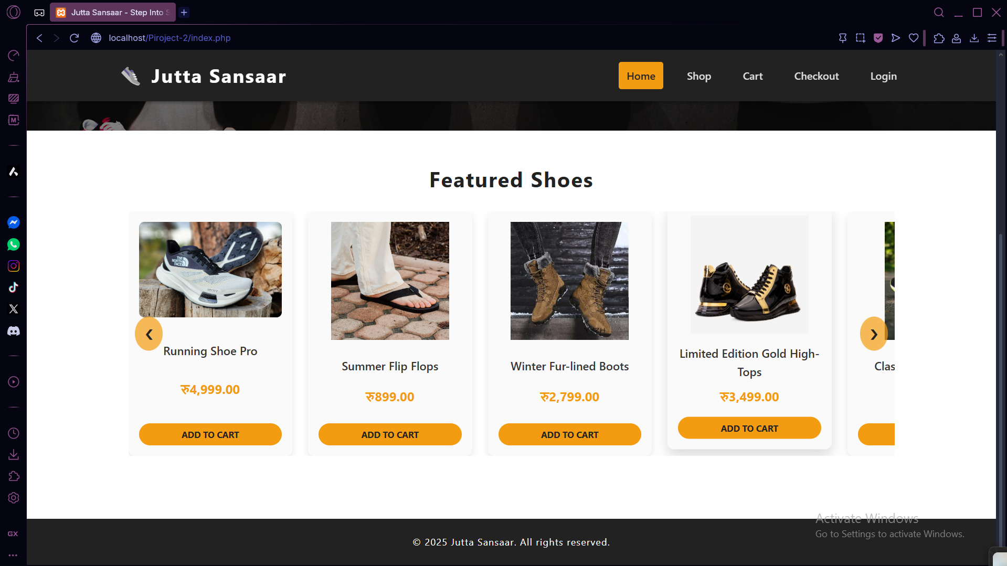

PRODUCT PAGE

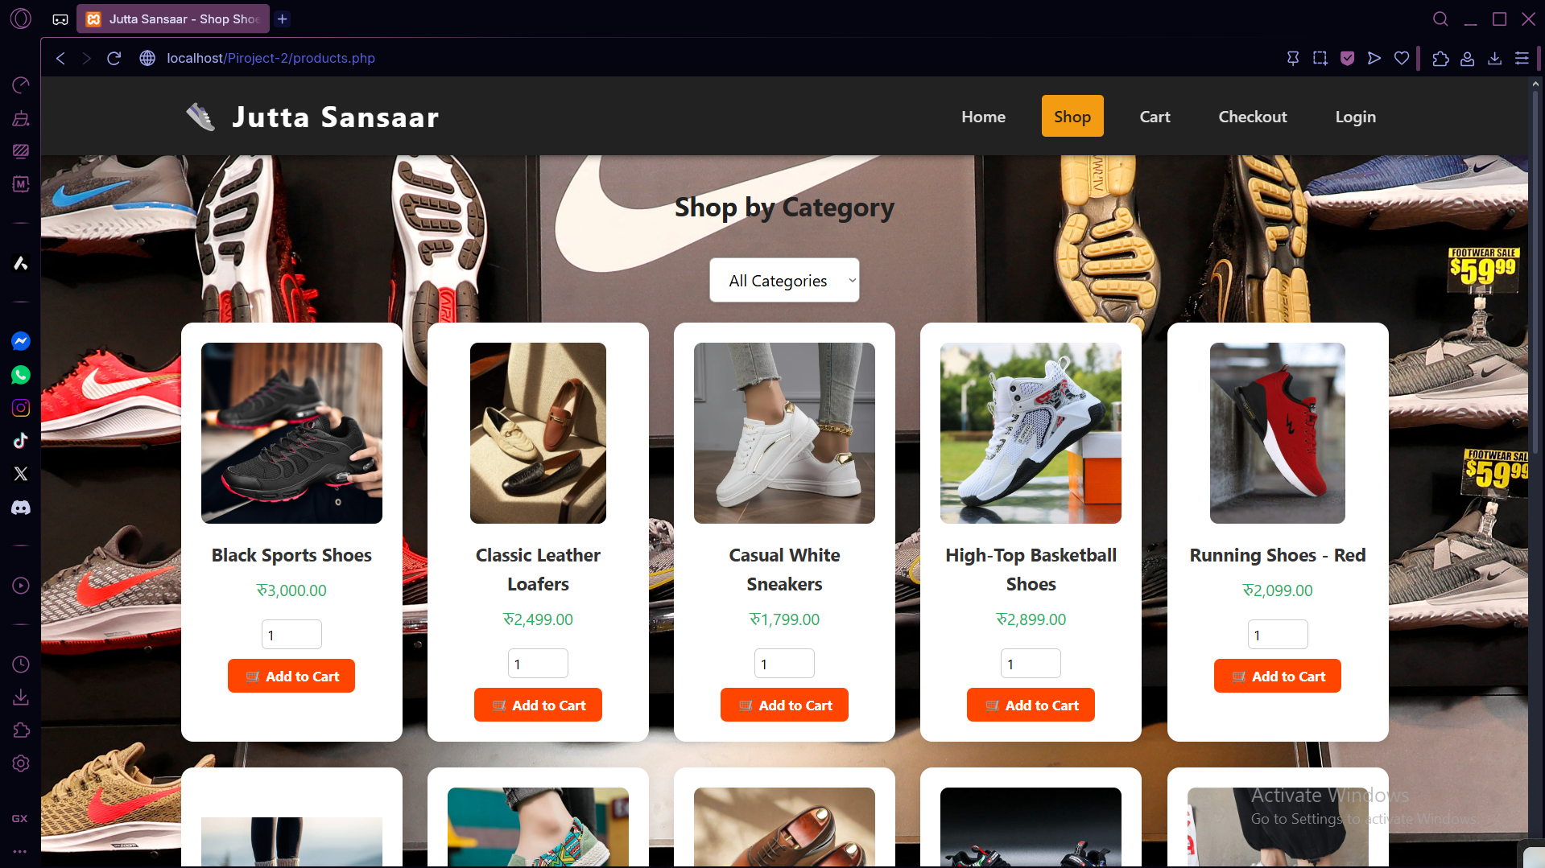

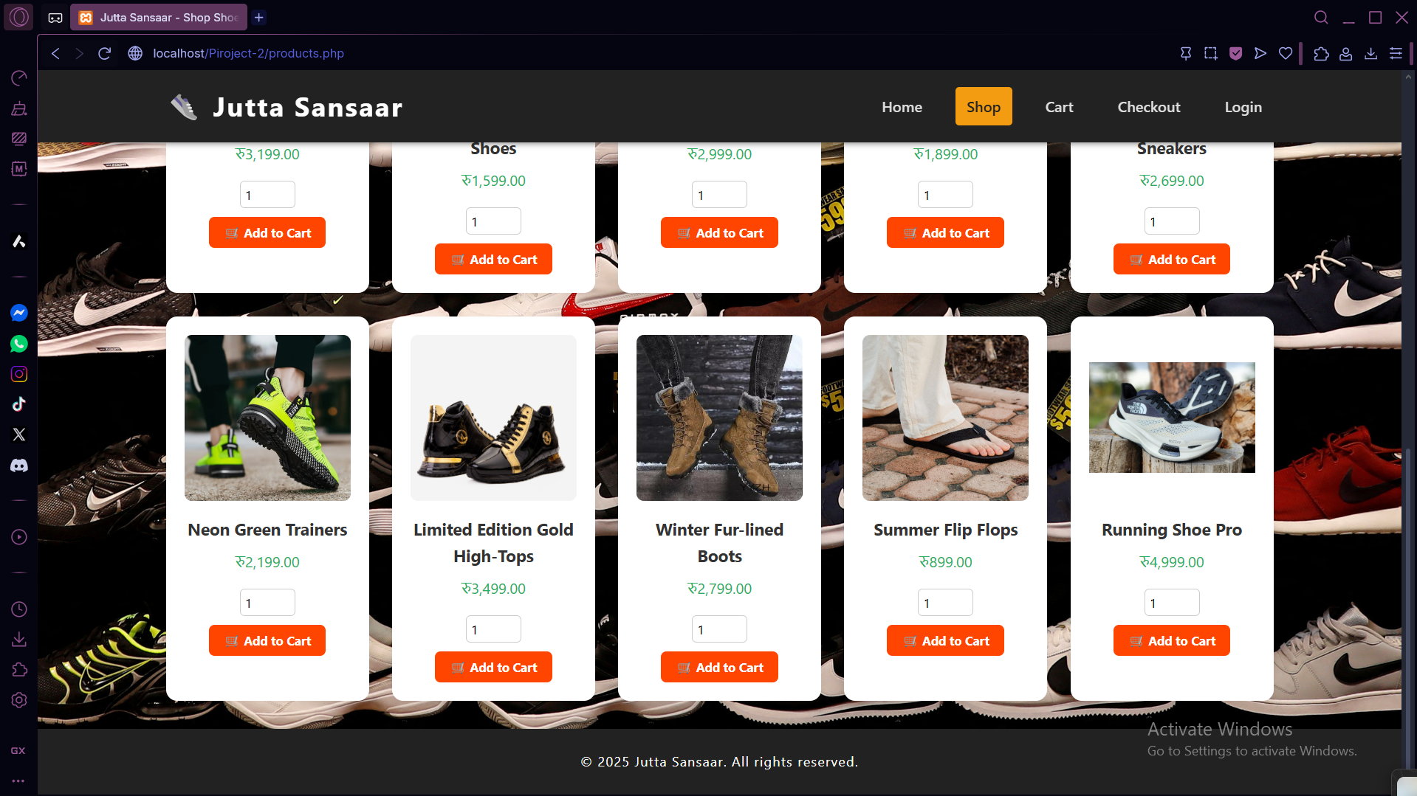

LOGIN PAGE

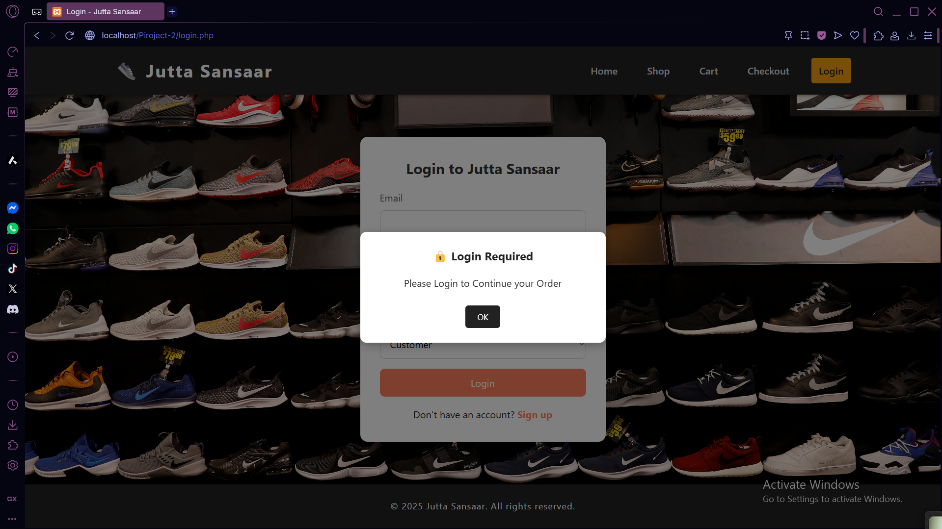

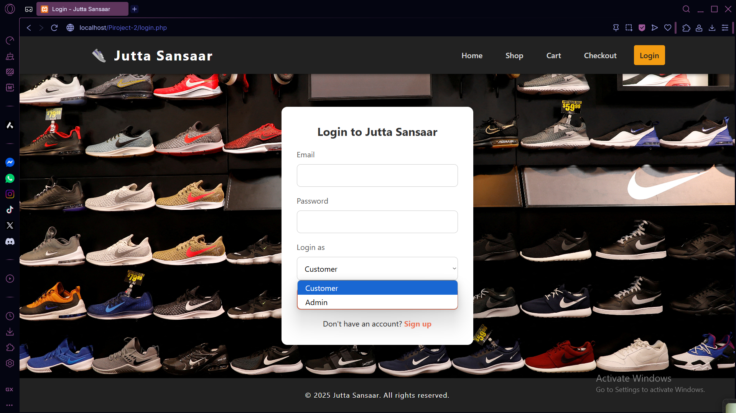

CART PAGE

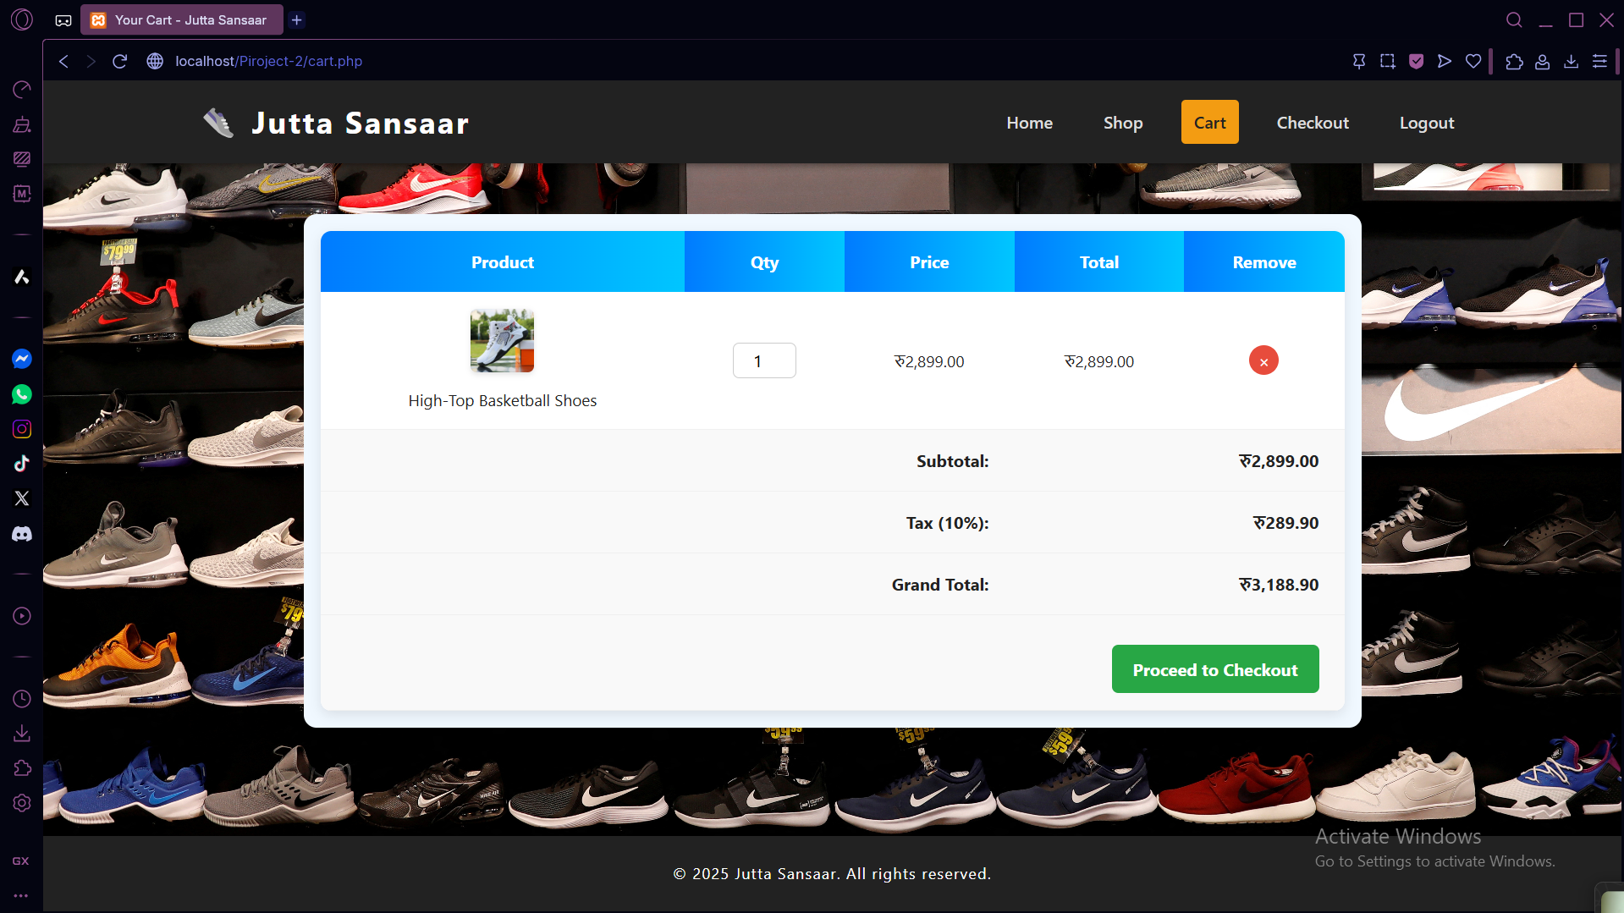

CHECKOUT PAGE

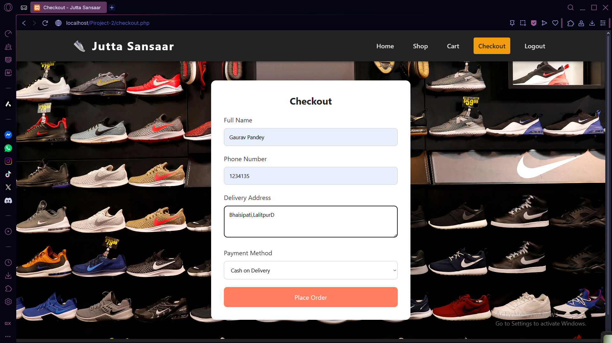

ADMIN DASHBOARD

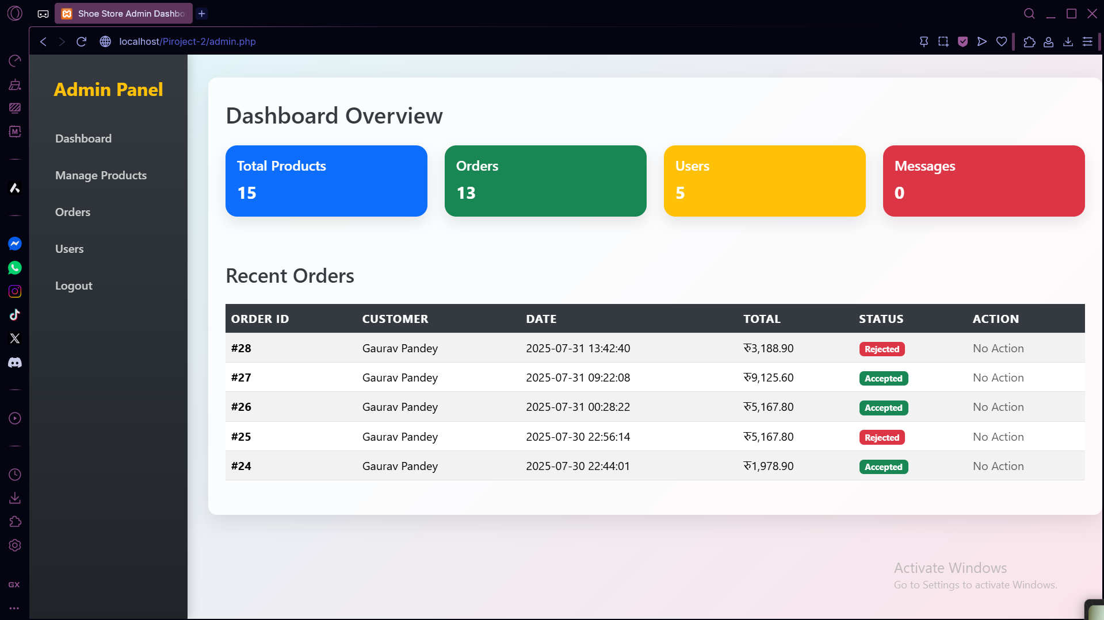

1. **GANTT CHART**

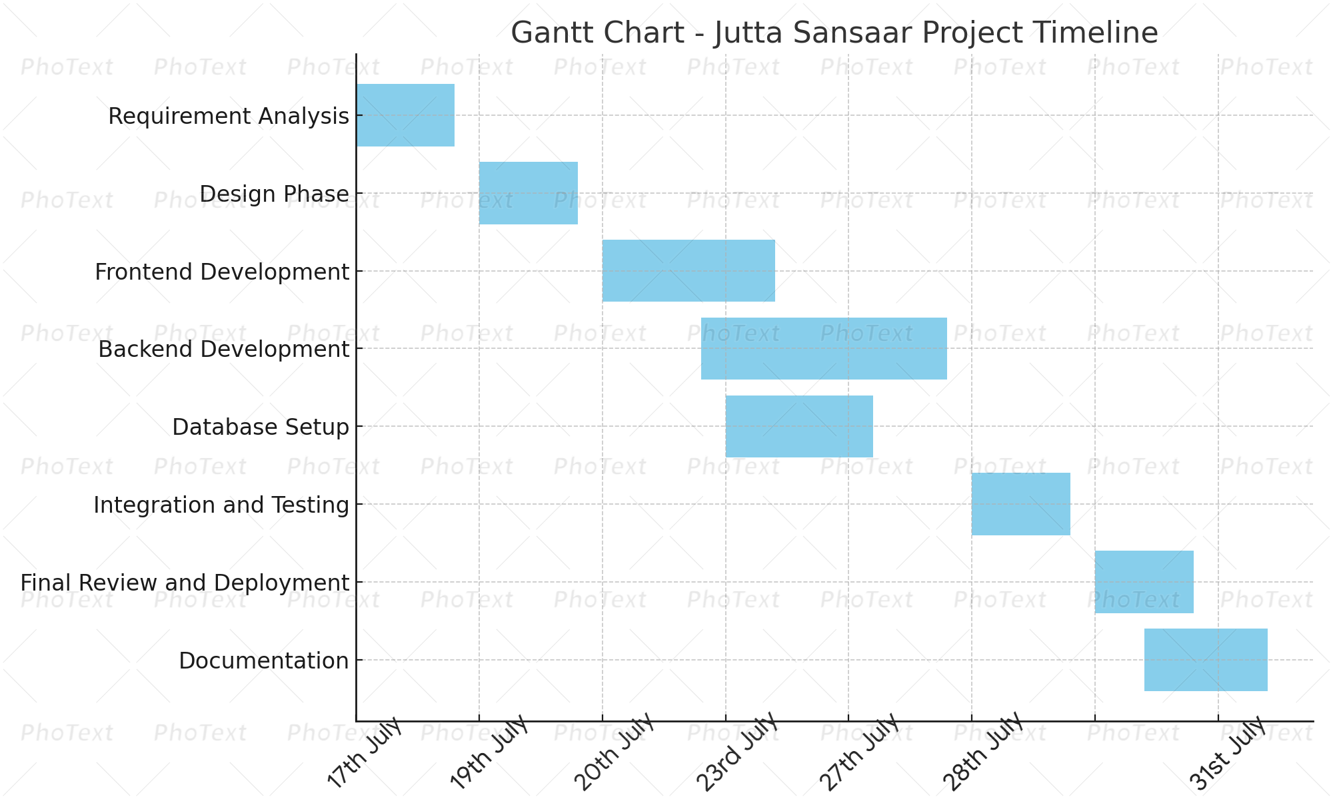

**Fig: Gantt chart of Jutta Sansaar**

**9. FUTURE EXTENSIONS**

Some of the extensions we have planned are:

1. **Payment Gateway Integration**  
   To enhance real-world usability, integrating a secure online payment gateway such as Khalti, eSewa, or Stripe will allow customers to pay directly via digital wallets or cards.
2. **Delivery Tracking System**  
   Implementing a basic order tracking feature will increase customer satisfaction by providing updates on delivery status.
3. **Customer Reviews and Ratings**  
   Enable product reviews and rating functionality to boost customer engagement and trust.
4. **Wishlist Functionality**  
   Add an option for users to save products for later purchase through a wishlist system.

**10. CONCLUSION**

The **“Jutta Sansaar”** project successfully delivers a fully functional e-commerce website tailored to the footwear retail industry. By integrating features like product categorization, size selection, shopping cart, secure login, order tracking, and payment methods, it provides a seamless user experience for both customers and admins.

This project helps local businesses establish an online presence, increase customer reach, and modernize retail operations. With a scalable architecture and secure backend, it sets a strong foundation for future upgrades such as mobile app integration, personalized recommendations, and real-time delivery tracking.

**11. REFERENCES**

|  |  |
| --- | --- |
| [1] | K. D. R. P. Amar Neupane, "daraz.com.np," 2016. [Online]. Available: www.daraz.com.np. [Accessed 06 06 2025]. |
| [2] | J. Bezos, "Amazon.com," Amazon MGM Studios, 05 07 1995. [Online]. Available: https://www.amazon.com. [Accessed 06 06 2025]. |
| [3] | Microsoft, "Microsoft Copilot," Microsoft Corporation, 30 July 2025. [Online]. Available: https://copilot.microsoft.com/. [Accessed 30 July 2025]. |
| [4] | R. Data, "Web development tutorials," W3Schools, 30 July 2025. [Online]. Available: https://www.w3schools.com. [Accessed 30 July 2025]. |
| [5] | Y. Creators, "Full stack development tutorials," YouTube, 30 July 2025. [Online]. Available: https://www.youtube.com. [Accessed 30 July 2025]. |

**APPENDICES**

INDEX PAGE





PRODUCT PAGE





LOGIN PAGE





CART PAGE



CHECKOUT PAGE



ADMIN DASHBOARD



